

**Department of Electrical & Computer Engineering**

**North South University**

**Final Assignment 2**

**Submitted By**

**Name:** Mohammed Mahmudur Rahman

**Student ID:** 1520386043

**Course:** Introduction to Communication (EEE321.L)

**Submitted to**Shajnush Amir

1. **Compare AM, FM and PM in details**

**AM:**

AM stands for amplitude modulation. It is a technique where the amplitude of the carrier changes according to the amplitude of the message or modulating signal.

It is used most commonly for transmitting information via a [radio](https://en.wikipedia.org/wiki/Radio) [carrier wave](https://en.wikipedia.org/wiki/Carrier_wave). Here, the amplitude (signal strength) of the carrier wave is varied in proportion to that of the message signal being transmitted

This technique contrasts with frequency modulation, in which the frequency of the carrier signal is varied, and phase modulation, in which its phase is varied.

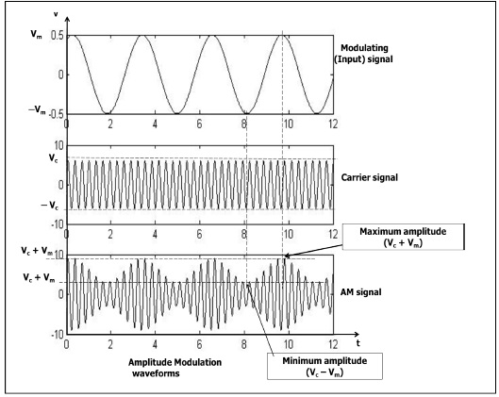

Figure 1: Amplitude Modulation Waveform

There are different forms of AM:

* Conventional Amplitude Modulation (DSB-LC)
* Alternatively known as Full AM or Double Sideband with Large carrier (DSB-LC) modulation
* Double Side Band Suppressed Carrier (DSBSC) modulation  Single Sideband (SSB) modulation
* Vestigial Sideband (VSB) modulation

**Advantages of amplitude modulation :**

* Simple to understand and implement.
* Requires limited bandwidth.
* Need low frequency carrier.
* less costly compared to frequency **modulation**.
* To use for long distance propagation.

**The disadvantages of amplitude modulation include the following.**

* The efficiency of this modulation is very low because it uses a lot of power
* This modulation uses amplitude frequency several times to modulate the signal by a carrier signal.
* This declines the original signal quality on the receiving end & causes troubles in the signal quality.
* AM systems are susceptible toward the generation of noise generation.
* The applications of amplitude modulation limits to VHF, radios, & applicable one to one communication only

**FM:**

FM stands for Frequency Modulation. In this modulation technique, frequency of the carrier changes according to the amplitude of the message or modulating signal. It is used to encode data on an alternating digital or analog signal. The method includes varying the frequency of the carrier wave on which useful information is imposed or impressed upon

**Different form of FM:**

Narrow Band FM:

Narrow band FM is defined as an FM transmission where the value of B is small enough that the terms in the Bessel expansion, i.e. sidebands are negligible.

Wide Band FM:

Wideband FM is defined as the situation where the modulation index is above 1. Under these circumstances the sidebands beyond the first two terms are not insignificant.

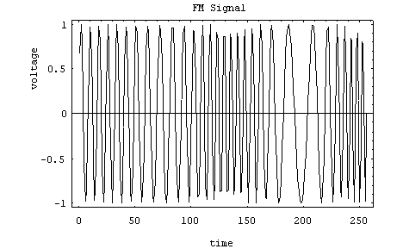

Figure 2: Simple FM Signal

Here, the carrier is at 30 Hz, and the modulating frequency is 5 Hz. The modulation index is about 3, making the peak frequency deviation about 15 Hz. That means the frequency will vary somewhere between 15 and 45 Hz. How fast the cycle is completed is a function of the modulating frequency.

**The advantage and disadvantages of FM are:**

|  |  |
| --- | --- |
| **Advantages** | **Disadvantages** |
| Less interference and noise. | Equipment cost is higher. Has a large bandwidth. |
| Power Consumption is less as compared to AM. | The receiving are of FM signal is small. |
| Adjacent FM channels are separated by guard bands. | The antennas for FM systems should be kept close for better communication. |

**PM:**

PM stands for Phase Modulation. In this modulation technique, phase of the carrier changes according to the amplitude of the message or modulating signal. It modulation pattern for conditioning communication signals for transmission. It encodes a message signal as variations in the instantaneous phase of a carrier wave. This modulation is the combination of two principal forms such as frequency modulation and angle modulation. The carrier signal’s phase is modulated to follow the amplitude of the message signal. Both pinnacle amplitude, as well as the carrier signal’s frequency, is maintained stable, although when the message signal’s amplitude changes, then the carrier signals phase also changes. Phase Modulation can be defined as the Phase of the carrier (Ø) signal is varied proportional to (in accordance with) the Amplitude of the input modulating signal.

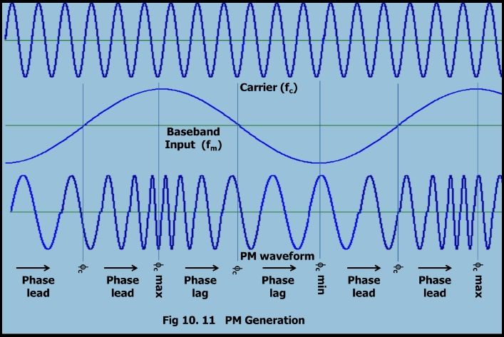

Figure 3: Phase modulation waveform

The **phase modulation diagram**is shown above. The carrier phase deviation will be more if the input signal amplitude increases and vice versa. When the input amplitude increases (+ve slope) the carrier undergoes phase lead. When the input amplitude decreases (-ve slope) the carrier undergoes phase lag.

**The advantages of phase modulation include the following:**

* Phase modulation (PM) is a simple contrasted to Frequency modulation (FM).
* It is used to find out the velocity of a target by removing Doppler data. This needs constant carrier which is achievable during phase modulation however not in FM (frequency modulation).
* The main benefit of this modulation is signal modulation because it permits computer for communicating on high-speed using a telephone system.
* When the information is being transmitted without intrusion then the speed rates can be observed.
* And one more advantage of PM (phase modulation) is improved immunity toward the noise.

**The disadvantages of phase modulation include the following:**

* Phase modulation needs two signals by a phase variation among them. Through this, both the two patterns are required like a reference as well as a signal.
* This type of modulation requires hardware which obtains more complex due to its conversion technique.
* Phase ambiguity arrives if we exceed index pi radian of modulation (1800).
* Phase modulation index can be enhanced by employing frequency multiplier.

**Answer to question no: 2**

MATLAB Code:

%name: Mohammed Mahmudur Rahman

%ID# 1520386043

%Section: 03

clc, clear all;

A= [66 55 44 33 22 11] ;

n= length(A);

for i= 1 : 1 : n;

Matrix(i,i)= A(i);

end

Matrix

Output:

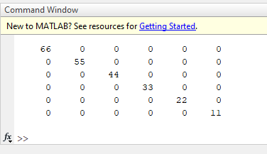

**Answer to question no: 3**

MATLAB CODE:

%name: Mohammed Mahmudur Rahman

%ID# 1520386043

%Section: 03

clc, clear all;

fs= 8000;

fc= 300;

t= [0: 1: 5*fs]/fs;

x= sin(20*pi*t) + 2*sin(40*pi*t);

y= ammod(x,fc,fs);

z= ssbmod(x,fc,fs);

p= amdemod(x,fc,fs);

q= ssbdemod(x,fc,fs);

subplot(5,1,1);

plot(t,x);

legend('Message Signal');

title('Name: Mohammed Mahmudur Rahman, ID# 1520356043. sec# 03');

subplot(5,1,2);

plot(t,y);

legend('DSB Modulated Signal');

title('Name: Mohammed Mahmudur Rahman, ID# 1520356043. sec# 03');

subplot(5,1,3);

plot(t,z);

legend('SSB Modulated signal');

title('Name: Mohammed Mahmudur Rahman, ID# 1520356043. sec# 03');

subplot(5,1,4);

plot(t,p);

legend('DSB demodulated signal');

title('Name: Mohammed Mahmudur Rahman, ID# 1520356043. sec# 03');

subplot(5,1,5);

plot(t,q);

legend('SSB Demodulated signal');

title('Name: Mohammed Mahmudur Rahman, ID# 1520356043. sec# 03');

Graph :

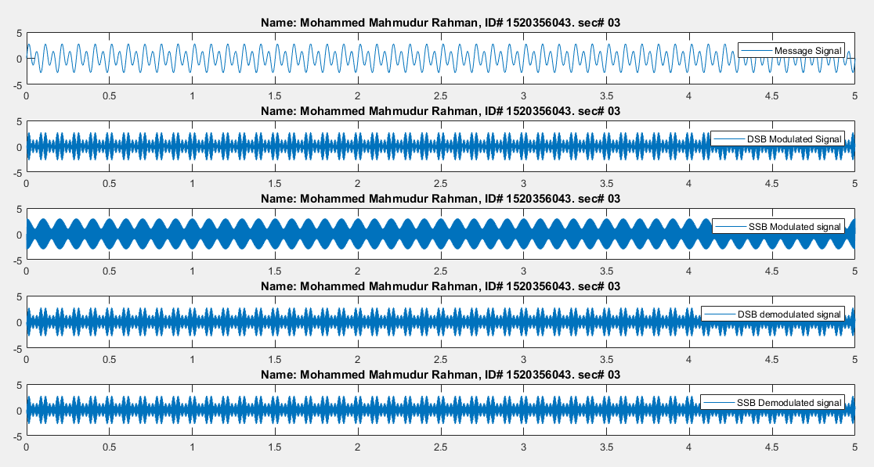

**Answer to question no: 4**

MATLAB CODE:

%name: Mohammed Mahmudur Rahman

%ID# 1520386043

%Section: 03

clc, clear all;

fc= 50;

dev= 10;

fs=1000;

t=[ 0: 1: fs]/fs;

x= sin(6*pi*t);

y= fmmod (x,fc,fs,dev);

z=fmdemod(y,fc,fs,dev);

subplot (4,1,1);

plot(t,x);

legend('message signal');

title('Name: Mohammed Mahmudur Rahman, ID# 1520356043. sec# 03');

subplot (4,1,2);

plot(t,y);

legend('FM modulated signal');

title('Name: Mohammed Mahmudur Rahman, ID# 1520356043. sec# 03');

subplot (4,1,3);

plot(t,x);

legend('FM demodulated signal');

title('Name: Mohammed Mahmudur Rahman, ID# 1520356043. sec# 03');

Graph: